**2.4 Deployment View**

The deployment diagram shows the architecture of the system. As mentioned before, system architecture is 3-tier architecture. However, in addition to presentation, logic and data layer there is also intermediary web tier to support third parties to access to the system by web browser. So, we can divide system architecture into 4 tiers.

* The first tier is the presentation tier: It’s composed by the mobile applications and web application which is used by the third parties. Mobile application has Data Acquisition Component to retrieve data from smart devices.
* The web tier contains web server which is implemented by Apache Tomcat and communicates the application tier using RMI.
* The application tier consists of Glassfish which handles all the business logic, connecting external services and data tier.
* The data tier is mainly composed by the Database Server. Connection between application tier and data tier is performed via JDBC connector.

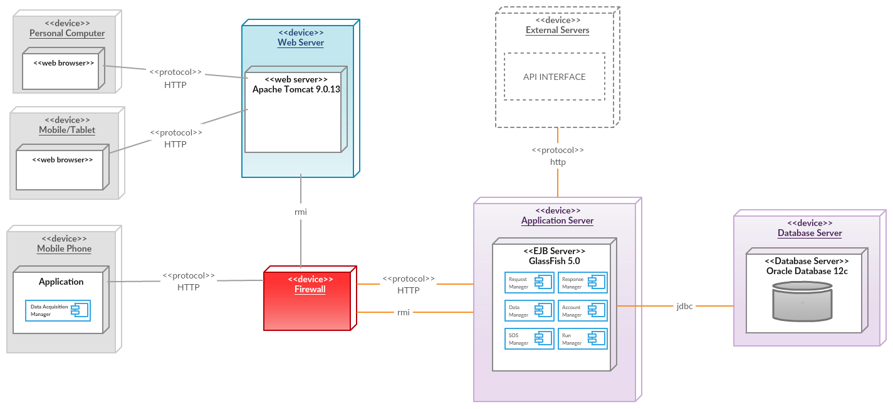

*Figure 2.4 Deployment View*

**Recommend Implementation**

* **Client Tier**: Mobile application can be implemented using a cross platform development tool such as Cordova which is an is an open-source mobile development framework. It allows you to use standard web technologies - HTML5, CSS3, and JavaScript for cross-platform development.
* **Web tier**: Frontend of web application can be implemented using HTML5, CSS(Bootstrap), Angular.
* **Application tier**: The EJB application server uses java beans to implement business logic and stores data to a persistent database using JPA.
* **Data tier**: The database can be implemented with Oracle database 12c.

**Reference**

**https://cordova.apache.org/docs/en/latest/guide/overview/index.html**